**Checkpoint 5 documentation**

**VAN LINH HA**

**116592171**

Brief Contents

I. Download Quagga 1

II. Quagga Configuration 1

# Download Quagga

* Make sure Router has an Internet to download the package
  + Use this command to install Quagga

**Yum install quagga -y**

# Quagga Configuration

* After downloading Quagga, copy the sample file to ospf folder

**cp /usr/share/doc/quagga-XXXXX/ospfd.conf.sample /etc/quagga/ospfd.conf**

* Start OSPF Service

**Systemctl start ospfd**

* Enable OSPF Service

**Systemctl enable ospfd**

* Give permission to ospfd.conf file

**Chown quagga:quagga /etc/quagga/ospfd.conf**

* Configuration
  + Type the command: **vtysh**  to log in the configuration mode

**Configure terminal**

**Router ospf**

**Router-id 10.40.105.226 (**router id is your interface which connects to the Internet**)**

**Network 10.40.105.0/24 area 0**

**Network 195.165.17.0/192 area 0**

**Network 195.165.17.64/30 area 0**

**Network 195.165.17.68/30 area 0**

**Do write**

* Make sure there is no iptables rules drop the OSPF Packets

1. **Apache**

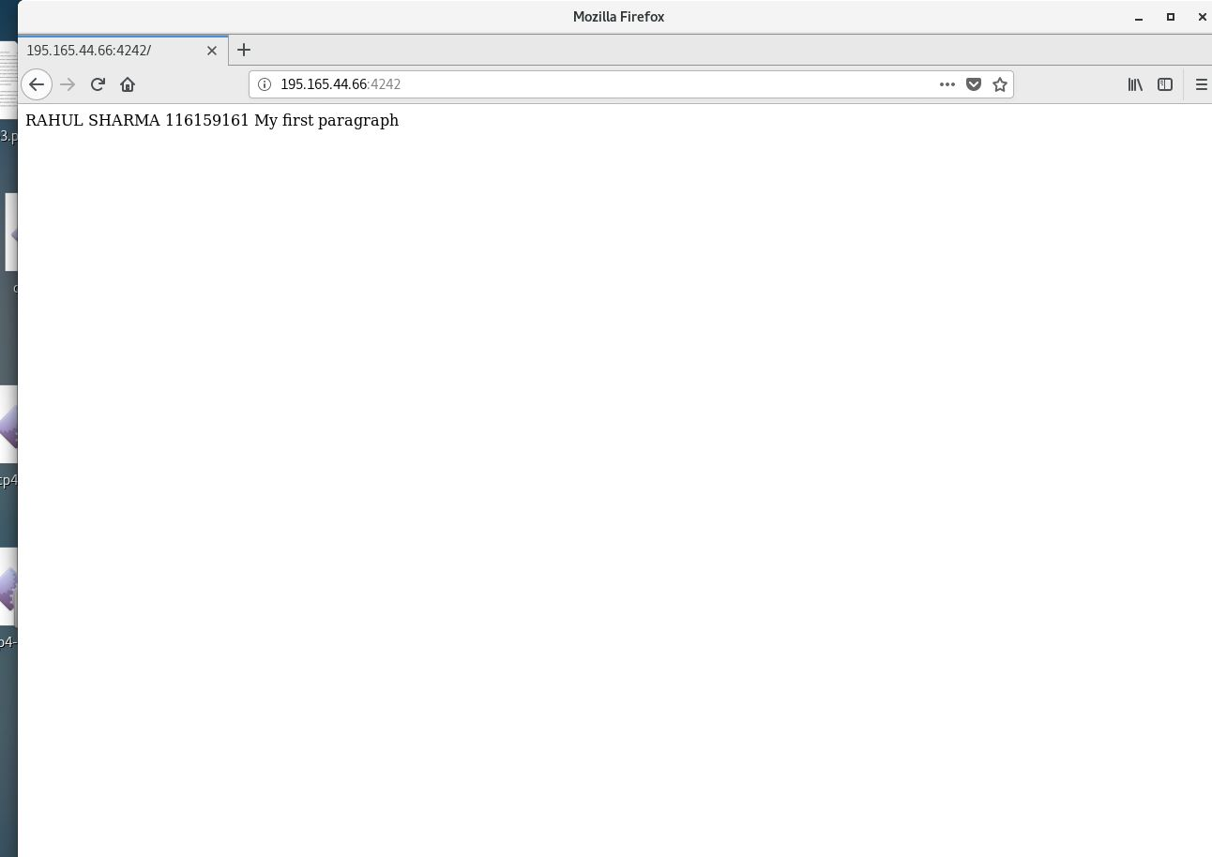

1. **IIS**

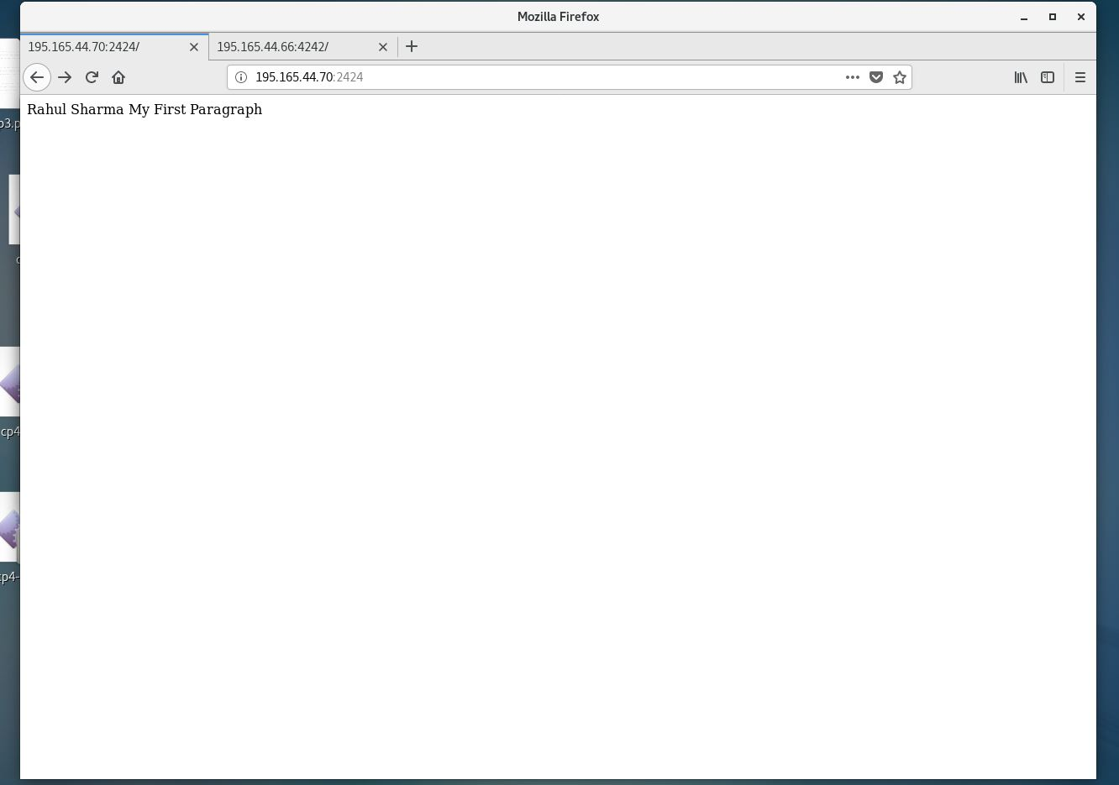

1. **MYSQL**

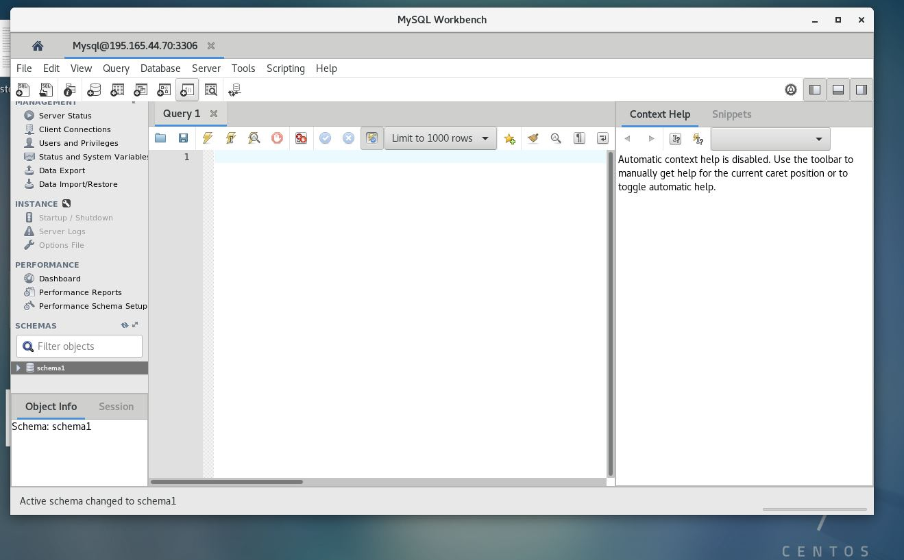

1. **SCP**

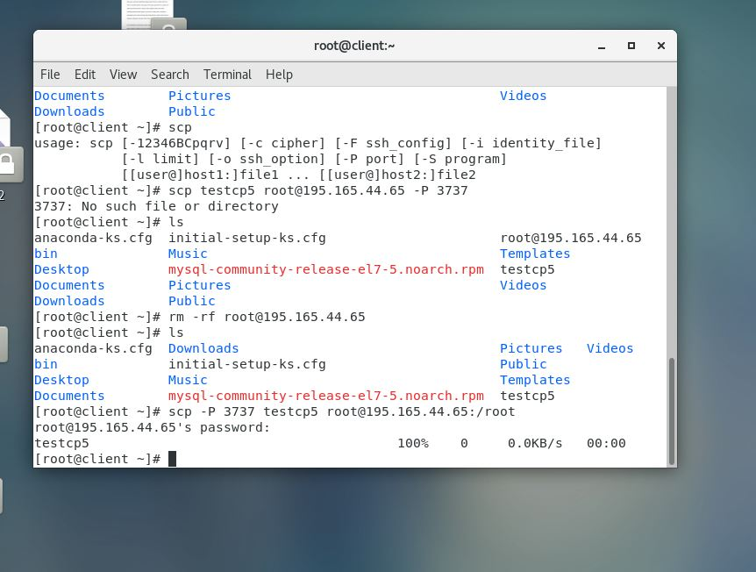

1. **SSH**

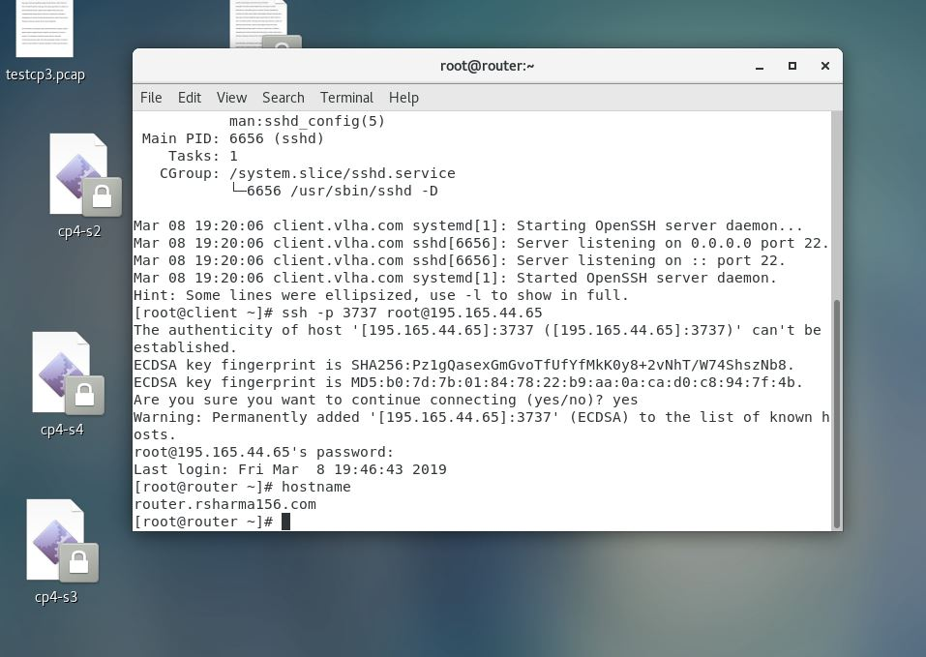

1. **FTP**

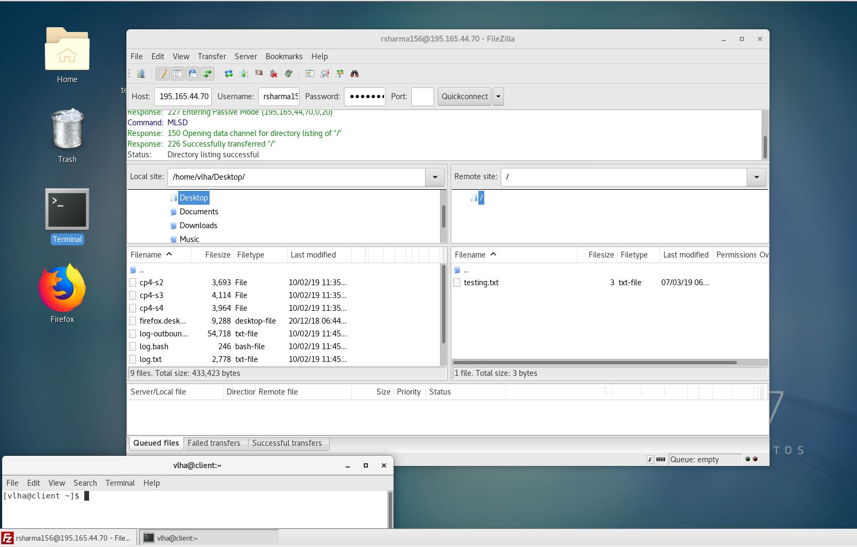

1. **ROUTING TABLE**

